Supplementary Materials
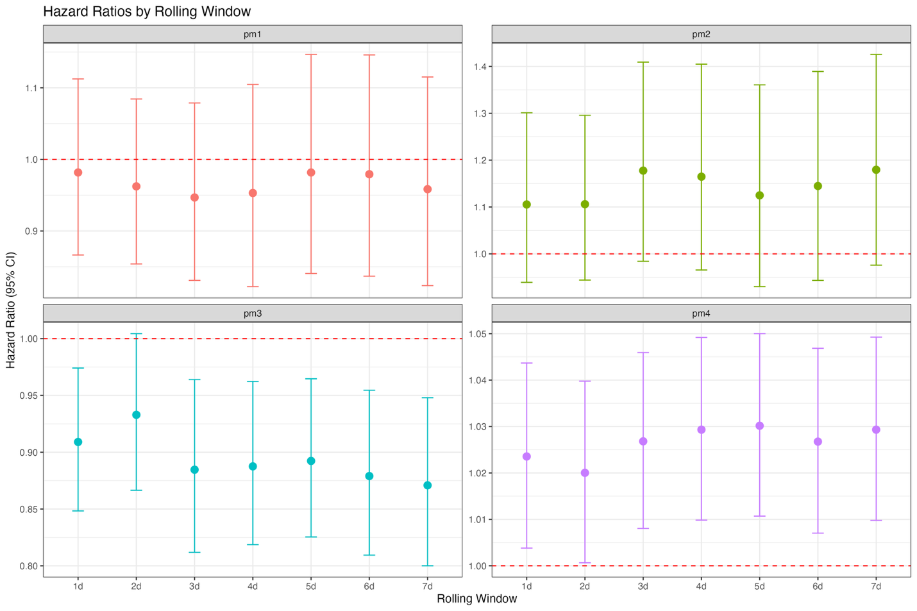
Supplementary Figure 1. Sensitivity analysis of the association between PM_{2.5} exposure and recurrent ALRI events across alternative exposure windows. Hazard ratios and 95% confidence intervals were estimated using Andersen-Gill models with rolling exposure windows from lag 1 to lag 7.

Supplementary Table 1. Model fit statistics effects from alternative recurrent event models. Akaike Information criterion (AIC) values and hazard ratios with 95% confidence intervals are reported for Andersen-Gill, PWP total-time, PWP gap-time, and shared frailty models.
Model | AIC
Andersen-Gill | 1971.6
PWP total-time | 1748.5
PWP gap-time | 1792.2
Frailty (Gaussian) | 2644.3
Frailty (Gamma) | 2862

